

**Training for Taught Postgraduate Course Representatives**

**Handbook**

**Introduction**

Congratulations on becoming a course representative! Representing the views of students about their learning experience is important at all levels, not least in taught postgraduate courses where things can often work very differently from the undergraduate level.

sparqs(**s**tudent **par**tnerships in **q**uality **s**cotland) is an agency that aims to improve student engagement in quality enhancement in universities and colleges. One way in which it does so is through the provision of various Course Rep Training modules across Scotland. This is one such module.

You will hopefully have received Introductory Course Rep Training, either previously as an undergraduate or earlier in this term.

By the end of this session you will be able to:

* + Understand course representation at PGT level and the work involved in being a PGT course rep.
  + Describe the importance of partnership between staff and students in shaping the PGT learning experience.
  + Explain the PGT Student Learning Experience and how you can use it to assist you in your work as a course rep.
  + Reflect on the skills you will use as course rep.

This handbook has been designed to record the work you will be doing during the training. It is also designed to be used as a reference tool during your time as a rep.

For further information about the course rep role and our wider work in supporting engagement in quality, please visit our website [www.sparqs.ac.uk](http://www.sparqs.ac.uk).

**Communication with staff**

Think about the nature and features of PGT study. What opportunities and challenges does this present for how you engage with staff in shaping the learning experience? Think about the impact of concepts like partnership and professionalism in your engagement with staff.

How can you employ the ABCD of Effective Feedback?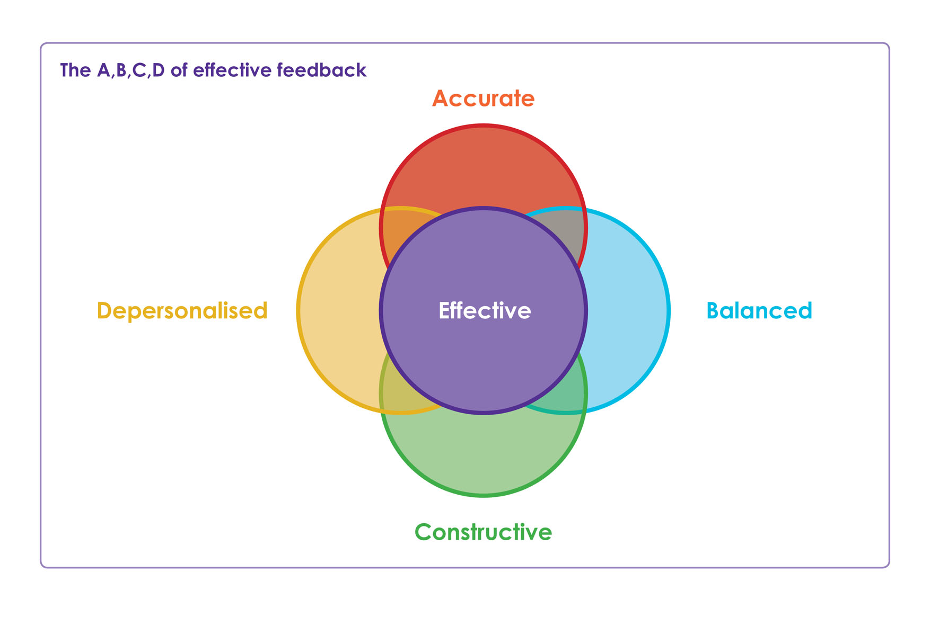

**Communication with students**

The course rep is an important conduit between the students studying a course, the teaching staff, and the students’ association. In terms of students, you will speak to three distinct groups very frequently, possibly even on a daily basis.

**Students on your course**

What are the best methods of communicating with the students you represent, whether that is on a specific module or on the degree as a whole?

Bear in mind the impact on this of:

* The mix of domestic and international students.
* The number of students studying online or at a distance.
* Whether students are studying part-time or full-time.

**Other course reps**

Think about communication with other reps – including undergraduate course reps in your subject area, fellow PG course reps (whether taught or research), or indeed reps elsewhere in the university.

What might you learn from and share with them?

**The students’ association**

How do (or should) PGT students’ views help shape the SA’s work at a university level on shaping the learning experience? What do you need from the SA in terms of further support or information?

**The PGT Student Learning Experience**

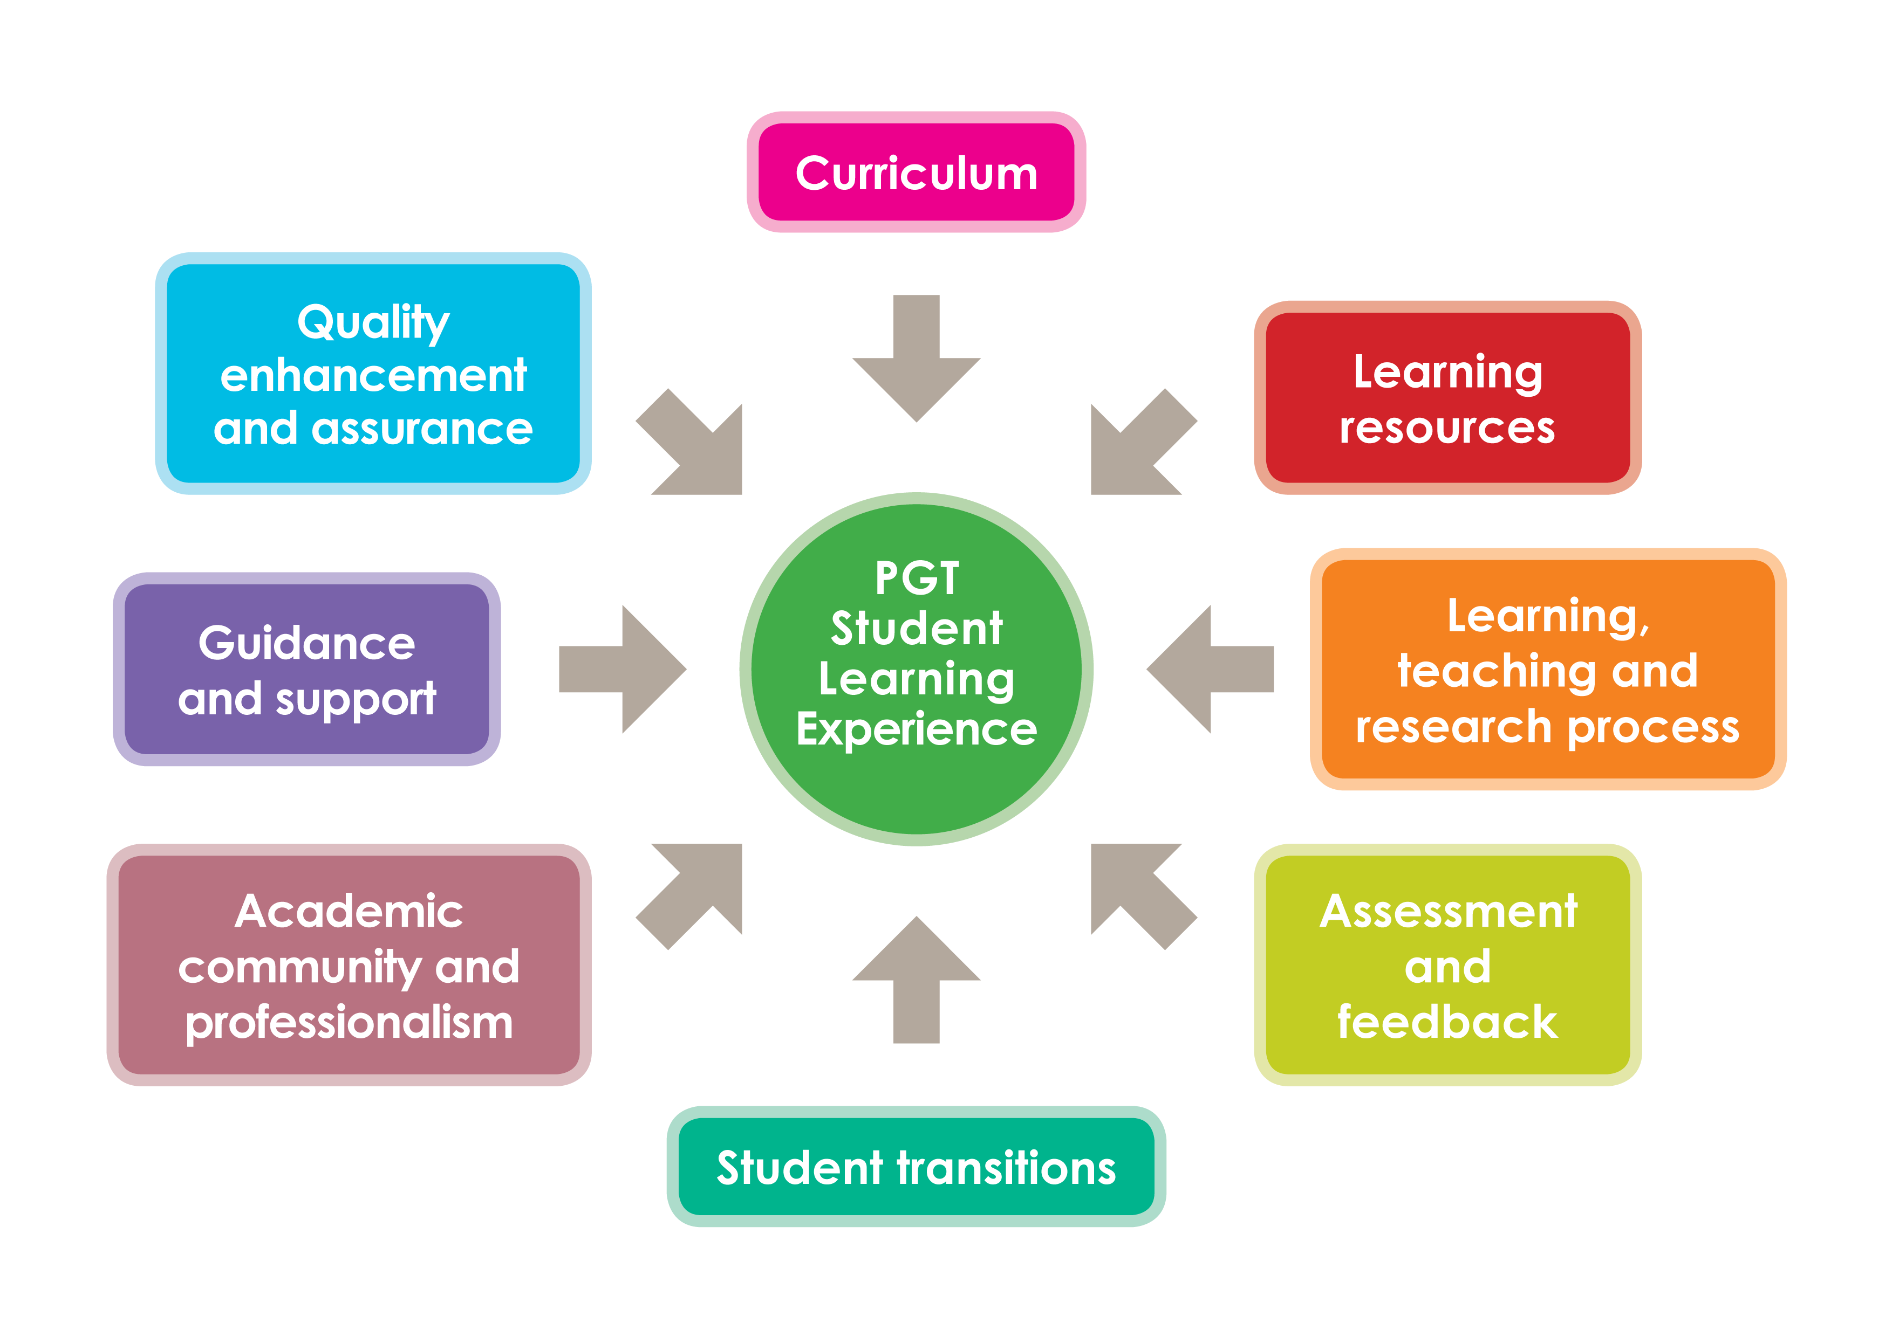

The Student Learning Experience is a way of turning what is a very large, broad concept into a set of meaningful, bitesize headings. By looking at your learning experience, and those of your fellow students, through the prism of these headings, you can get specific, relevant ideas and suggestions based on students’ views. You can then work with staff to explore how these ideas might enhance the learning experience.

Under each heading there are a set of questions that you can use to generate discussion with the students you represent.

**Curriculum**

At PGT level study you’re probably looking to be more in control of your education and want to manage your educational experience more than you may have at undergraduate level. The curriculum needs to have the breadth and variety to make this possible, to give PGT students enough flexibility to enable autonomy, while still benefiting from the expertise of staff. A wide choice of topics should be available to you to allow you to create the course that best meets your academic needs and interests. You should have adequate information on the purpose of the course along with expectations of what you will achieve, but beyond this, you and fellow students should be able to shape your learning outcomes and how you can achieve them.

Consider:

* Are students involved in designing and shaping the course’s learning objectives?
* How well is the autonomous nature of PGT study explained to students and at what point?
* Are students offered a wide range of subjects to allow them to create a course that meets their own needs?
* Is the curriculum flexible enough to allow students to adapt their studies to their academic expectations?

**Learning resources**

PGT students need access to appropriate learning resources, which encompasses a range of things from learning materials and physical work spaces to online and international communities. Access to introductory and academic networks should also be considered as learning resources. It can also encompass learning resources necessary to develop your study and research skills.

For example, a dedicated PGT study space can be useful as it allows students a space for more social or peer learning.

Consider:

* Are there adequate library and computing facilities?
* Do you have access to the up-to-date resources you need (for example, books, lab equipment and art materials)?
* Were you given adequate support to source additional resources as needed?
* Did departmental facilities meet your expectations?
* Were resources adequately available?
* Were you encouraged to use your peers or other academics to learn from?

**Learning, teaching and research process**

There is an expectation of higher engagement with the degree/classes/co-curricular activities related to the degree and this will require a different approach to learning and teaching. A range of approaches to delivering learning should be available to you that fulfil the learning objectives and the needs of the cohort. In some courses, this may also include work-related placements.

With so much of a PGT course involving independent research, clear processes for developing this along with clear expectations of what needs to be achieved will help students. It will require you to research more deeply and you may require support to learn to be a researcher.

Consider:

* Were you consistently/sufficiently guided to practice your skills throughout your course?
* How were the various aspects of teaching, learning and research co-ordinated and communicated to you?
* Are you able to learn in a way that suits you?
* How would you rate the teaching?
* How would you rate the research support?
* Are there any forms of learning you would like in addition to lectures and tutorials?
* Do you find the methods used a satisfactory method of imparting information?
* Did you feel your department/course prepared you sufficiently for your assessments?

**Assessment and feedback**

There is an expectation that PGT students’ assessment will largely be done through coursework rather than exams. Your coursework ideally should be well spaced and the purpose of it clearly explained – a link between the assessment and the outcomes of the course should be explicit.

PGT study is at a different level to undergraduate study and to support this change in approach it can be useful for you to be given an objective comparison of the skills you might need and a “performance review” of your development against this standard. PGT students also have higher expectations of their work, the corollary of which is you are likely to need deeper levels of feedback to support this.

As courses are usually only one year (if full-time) students have less time to change and adapt their work in response to feedback so alternative approaches, such as more frequent one-to-ones with tutors, or peer assessment and feedback, may help.

Consider:

* Does the assessment adequately and fairly fulfil one or more of the course’s learning objectives?
* Are you given a choice of assessment? Are there opportunities for blended learning?
* Was the assessment fairly marked following clear marking criteria?
* Do all the lecturers grade to the same standard?
* Is the style of assessment appropriate for meeting the course’s learning objectives?
* Do you receive adequate, timely enhancement feedback from your assessments?
* Is feedback given in a variety of ways, i.e. one-to-ones, peer review, written comments?

**Student transitions**

Moving to PGT study involves a range of transitions for the student. To a different level of study, maybe a different area of study, to a new department or school, possibly to a new institution, or to a new mode of study. There is also a transition into an academic and professional community, locally, nationally or internationally. Students will also transition out of PGT into further education or into the workplace.

The expectations of students in every area of transition needs to be explained, but without overwhelming you. Induction courses can be provided or made available, such as research skills and time management. As PGT is also a transition, onwards career development opportunities and guidance should be available. As well as making courses and support available, the rationale for them also needs to be clear and you should be encouraged and supported to access them.

Consider:

* What support was available to you to support the transition into PGT study?
* What additional training was available to you to support the increased work and depth of study?
* Did you have access to a member of staff who could provide appropriate academic support?
* How well were you connected to the wider academic community in your area of study?
* How much career or academic development support were you given to consider your future opportunities?

**Academic community and professionalism**

The nature of PGT study naturally means that you may well feel a closer connection to the department you are studying in than you may have as an undergraduate. And PGT students are also part of a wider academic community beyond your department or school. You probably want to feel connected to this academic community in order to learn and develop from it. PGT students are developing their academic identity and want the encouragement to develop and express their academic freedom within their subject areas that can come from being part of a wider academic community.

The wider academic community is multi-faceted and can incorporate connections to other students and academics, from within your own university and with others, and connections to industry or career professionals in their subject area. Opportunities for networking across these connections can enable you to develop your academic identity.

Consider:

* What opportunities there are for PGT students to access subject development opportunities within their institution?
* Do you have networking opportunities with students and academics from other universities?
* Are there career and industry networking opportunities?
* Do you feel supported to develop your academic identity? How can you evidence this?

**Guidance and support**

By this stage in your studies it is possible that the guidance and support is more in relation to academic guidance rather than broader educational support. Signposting in relation to writing assignments or to receive reasonable adjustments should be available. The availability and reliability of academic staff is important – you may well have a subject-specific advisor.

The sensitivity of how you, as course rep, raise concerns about your advisers and where students go if they have an issue should be clearly and regularly advertised.

You may also have a personalised development plan, which includes academic development, to help them achieve the learning outcome.

Consider:

* Do you have an allocated academic tutor appropriate to your subject area?
* Are you able to access your support tutor at times/in a way that supports your development?
* Do you have a personalised academic development plan?
* Are you able to access educational support such as disability services or help with assignment writing?

**Quality enhancement and assurance**

The final element is, in a way, the umbrella that draws all the other elements together. There are various processes by which the degree is monitored and continually improved – both by the course team and others across the faculty or university. Students should be playing a key part in this – whether by filling in module evaluation questionnaires, sitting on committees as you will as a course rep, getting involved in working groups or focus groups, or generally telling staff what you think about the course.

Consider:

* What evidence do you see that improvements are being made as a result of students’ views?
* To what extent do you or course mates feel that you should have a deeper role in this by virtue of the nature of PGT study?

**Scenarios**

The following scenarios are based on real situations described by PGT course reps in Scottish universities.

* What elements of the PGT Student Learning Experience do they relate to?
* What would you do as course rep in these situations?
* How could you develop solutions based on partnership working with staff?

**Scenario 1**

As promised in the pre-entry information about your course, the university has organised an interesting series of lunchtime talks relating to your subject. These include employability and research skills workshops from departmental staff, plus lectures by industry specialists and employers. However, two students contact you on the VLE to say that, although they live in the area, they can’t make the talks because they only study part-time and the talks are scheduled on a day when they’re in work. They’re unhappy to miss out, but haven’t raised it with staff.

**Scenario 2**

A student comes to you as they have been penalised for collusion. They are an international student, paying very high fees, and don’t understand what they did wrong. They have always studied collaboratively with other students and at home this study method is promoted as the best way to learn. They don’t want to be penalised again and risk failing their course, so they ask for your advice.

**Scenario 3**

You have volunteered to be a course rep but representation at postgraduate level is underdeveloped at your university. There is no Student Staff Committee in the department, at least that you know of, other students aren’t aware you are a course rep, and when you approach departmental staff they are reluctant to arrange meetings or promote course representation in the course.

**Scenario 4**

A student comes to you as they are having problems with their research project. They were delayed in being allowed to choose their topic and now that they are working on it, they feel that are not getting adequate support. Their supervisor is working abroad for several weeks and is only available at certain, rather inconvenient, times of the day by video-conference. The student is angry and they want your help to complain.

**Scenario 5**

You have just started being a course rep and a small group of students are frustrated about timetable clashes. They have three different classes that were scheduled at the same time meaning students who have chosen certain electives can’t attend one of the core classes. This is limiting their studies, and as they are fee paying students, they don’t feel this is fair.

**Scenario 6**

In your module’s student-only Facebook group, there has been discussion about the balance between two branches of the subject you’re studying. A large majority are unhappy that the reading list and content in the library is weighted towards one of the two, yet both feature equally in assessments. As the rep, you’re asked to raise a complaint about this. However, you disagree with the majority view because you’ve personally found plenty resources right across the content of the module and have always found staff helpful when you’ve asked about them.

**Meetings**

Think about your actions and approaches before, during and after meetings.

|  |  |  |
| --- | --- | --- |
| Before meetings | During meetings | After meetings |
|  |  |  |

**Next steps**

Think about your action points arising from this training session, your access to potential sources of support, and how you might develop as a result of the role.



sparqs

1 Papermill Wynd

Edinburgh

EH7 4QL

t 0131 622 6599

[www.sparqs.ac.uk](http://www.sparqs.ac.uk)

student partnerships in quality scotland (sparqs) is a Scottish Charitable Incorporated Organisation. Registration number SC046172

 Licensed under a Creative Commons Attribution Non-commercial 3.0 [licence](http://creativecommons.org/licenses/by-nc/3.0/).



You are free to copy, communicate and adapt the work, so long as you attribute sparqs.